Assignments 22.2

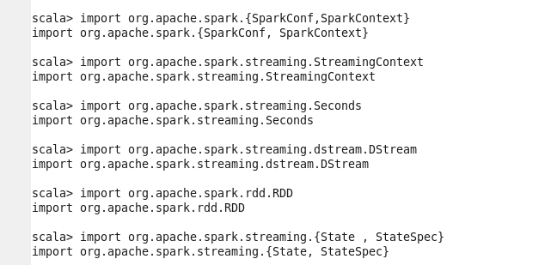

Kafka is downloaded:

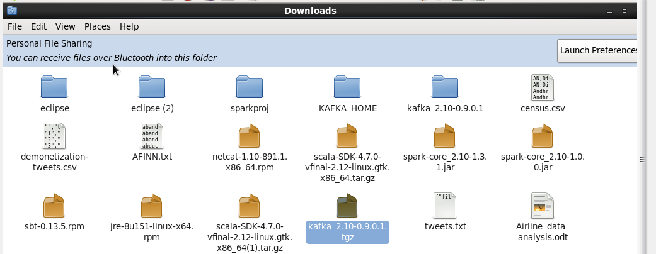

Getting below error while installing kafka:

